1. **Use relation used in Q3. Write a PL/SQL code using cursor to increment the salary by 1000 of those employee who belongs to department number 20 and print the number of rows affected during the operation.**

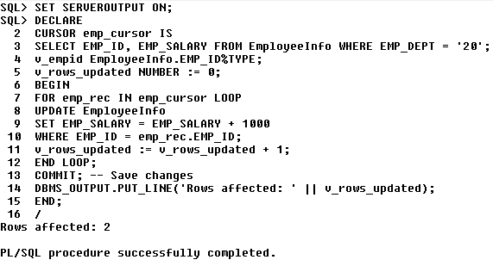

1. **Write a PL/SQL block to print E_ID and LNAME of first 10 employees**

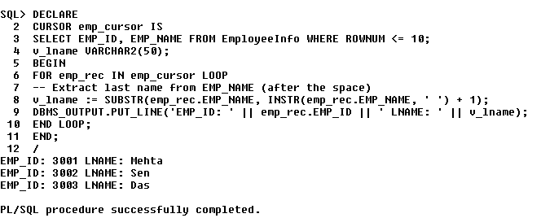

1. **Write a PL/SQL procedure to find minimum of two elements.**

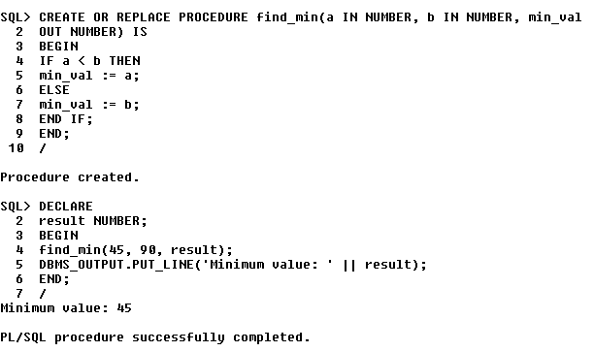

**4. Write a PL/SQL function to find minimum of two elements.**

